Team 9 Project Proposal
Explainable Natural Language Query Interface for Relational Databases Using a Multi-Agent System
BACKGORUND & VALUE PROPOSITION
Aim
Develop an explainable, multi-agent system that allows user to explore databases via natural language queries, providing visualisations and justification for the query output.

Background & Value Proposal
Relational databases remain central to enterprise data management, offering structured storage and reliable performance. Recent advancements in large language models (LLMs) have enabled tools that allow users to query databases in natural language, alleviating the need for technical SQL and data warehousing expertise. Such capabilities are increasingly integrated into platforms like Power BI and Tableau. However, these approaches often lack transparency and explainability, limiting their suitability in enterprise contexts where trust and accountability are essential. In addition to functioning as “black boxes,” these end-to-end models often struggle to adapt to different database scenarios, limiting their flexibility and practical applicability in enterprise settings.
Explain Spider
Key Challenges
- Query results must be transparent, enabling users to understand how each answer is generated rather than receiving only the final output.
- The framework for producing explainable results should be modular, allowing easy adaptation to different scenarios. Where adjustments are required, it should support fine-tuning of individual models rather than retraining the entire system.
To address these challenges, we propose an explainable Natural Language Interface for Database Exploration. The system would take a natural language query as input and invoke multiple agents to perform specialised tasks, making it easy to adapt to different database schemas by fine-tuning or replacing individual modules. By providing explanations for each agent’s results and presenting visualisations of relevant tables and records rather than only a final answer, the framework ensures transparency, adaptability, and actionable insights for enterprise users.

Key Benefits
- A Multi-Agent framework that is easily adaptable to different database scenarios, requiring only fine-tuning or replacement of individual modules instead of retraining the whole system.
- Interpretable outputs, presenting results through visualisations of relevant tables and records rather than only returning a final answer.
- A clear focus on adaptability and explainability as the core strengths of the proposed approach

DELIVERABLES & TIMELINE & COSTS

Deliverables
- Deliver an intelligent and explainable database exploration tool that allows users to input natural language queries and receive not only accurate results, but also a transparent reasoning process. This includes highlighting relevant tables and records, and providing insights into why specific records were selected and presented [4], [5].
Unlike traditional systems that merely return a result or generate SQL code, our solution emphasizes reasoning, transparency, and generalizability across diverse and previously unseen database schemas. By leveraging advanced Multi-Agent Systems (MAS) and AI techniques—such as Chain-of-Thought (CoT) reasoning, schema linking, and editable reasoning steps—we significantly enhance both accuracy and interpretability [1], [2], [11].
- Deploy an interactive web-based dashboard where users can input natural language queries and receive relevant tables with highlighted records and explanations for table/record selection [4], [5].
- Produce a comprehensive GitHub repository containing modular implementations of all agents, complete with data processing scripts, training logs, and evaluation reports, ensuring that any developer can reproduce results.
- Deliver an oral presentation and live demo showcasing system functionality, explainability, and user interface, along with a summary of the technical approach and achieved outcomes.
Timeline
Week(s) | Task Name | Description
W3–W4 | Research Tools & Frameworks | Investigate multi-agent system architectures (e.g., LangChain, custom pipelines), evaluate how agents will communicate and be orchestrated, and determine the most effective frameworks and tools for building and integrating the pipeline.
W3–W4 | Project Proposal & Scoping | Collaborate with the client to clarify project objectives, deliverables, and success criteria. Refine the technical and functional scope, document requirements, and submit project proposal. Ensure all team members understand the project vision and their roles moving forward.
W5 | Develop Individual Agents | Train and test each agent in isolation (Schema Intelligence, NL Understanding, Database/Table Selection, SQL Generation, Record Discovery). Link schema embeddings to Database Selector agent.
W6 | Pipeline Integration (Initial) | Connect agents in a sequential pipeline; establish data flow between components (architecture may not yet be fully functional).
W7 | End-to-End CLI Prototype | Achieve a working command-line version of the full pipeline capable of handling basic queries.
W8 | UI Development & Integration | Build and connect a web-based dashboard to the backend pipeline.
W8–W10 | Iterative Improvements | Improve accuracy; explore Spider v2 dataset support; implement query memory features.
W10–W12 | Finalisation & Reporting | Prepare presentation, polish codebase and UI, rehearse demonstration.

DELIVERABLE GANTT CHART – please see appendix

Costs
Monetary: There will be no costs incurred by the team. The only expense will be running our agents, for which the client has already provided an API key. We will be using GPT-5 mini, which costs USD $0.25 per 1M input tokens and USD $10.00 per 1M output tokens.
Time: The project is estimated to require a total of 400 hours of work from data scientists. This work is spread out among team members and weeks 5 to 12.

METHODS

For training and testing, we will use the Spider v1 dataset, focusing on easy and medium difficulty questions. We will also use ‘dataset split’, ensuring that all questions for a given database remain in the same split. This setup attempts our system’s capability to handle not only new questions, but also generalize to new databases and domains [3].
The project source code and documentation, including design documents, proposals, and final paper, will be managed using Github version control system, with built-in product managing features like tasks - issues, and virtual co-workspace.
Task 1: Design and deploy the core modules of the Agentic AI application
The project aims to experiment on multiple complex design increase with performance of the AI application. Multiple strategies may include but not limited to:
- Few shots prompting, database-aware (DAIL) [1].
- Schema linking with explicit linking prompts and foreign-key surfacing [1], [2].
- Decomposition prompts [2].
- Self-correction prompts [2].
- Agentic planning and tooling [3], [11].
To test the effectiveness of these strategies, we will design multiple structures of applications. Optional, editable reasoning can be implemented to allow users to modify the reasoning steps of the AI agents, providing both explainable capacity and performance [4], [5].

Task 2: Evaluate and optimise the performance of the designs
The performance of the Agentic AI application will be evaluated through a series of combinations by models and agentic AI techniques based on the Spider version 1 dataset's metrics that been proposed in the dataset's paper [1], [6]. Metrics that will be used are Exact-Match, Execution Accuracy, and other relevant metrics [1], [2].

Task 3: Design and deploy the explainable functionality for the Agentic AI application in the GUI of the application
To overcome the limited clarity of the reasoning process in the Agentic AI application, we will implement explainable function in the GUI of the application. These explanations will provide users with insights into the reasoning process of the AI agents, enhancing transparency and user understanding. The design may explore various visualization techniques, such as reasoning paths and tree, along with result presentation like chart, data table, SQL tables or other formats that can effectively increase the explainable capacity of the AI agents [4], [5].
4: Evaluate the effectiveness of the explanation in the Agentic AI application in enhancing the AI agents' performance and user satisfaction.
The effectiveness of the explanation will be evaluated through user studies and performance metrics using surveying techniques. User studies will involve gathering feedback from users on the clarity and usefulness of the explanations provided by this interactive tool as well as their impact on user satisfaction and trust in the AI agents. Each of the metrics will be evaluated and the overall feedback also collected. The space of evaluation samples will include a diverse range of user interactions and scenarios, based on the Spider data set and SQL potential tasks to ensure comprehensive evaluation [4], [5].

APPENDIX

Deliverable Gantt Chart
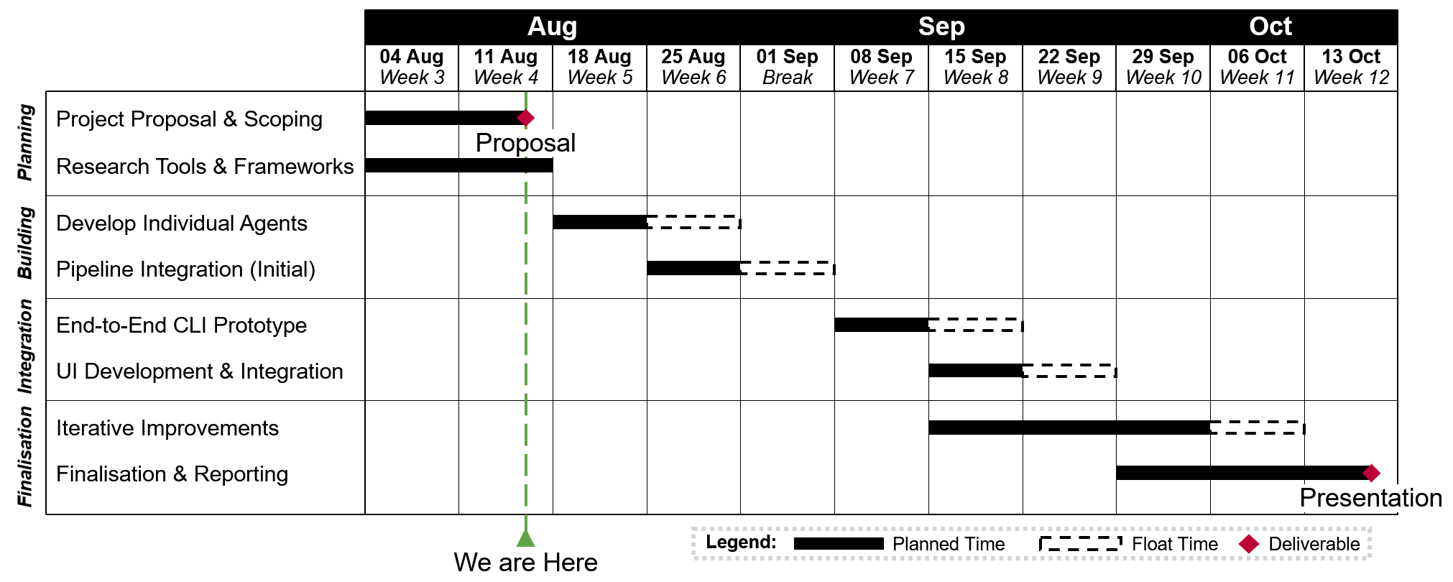

REFERENCES

[1] D. Gao et al., “Text-to-SQL empowered by large language models: a benchmark evaluation,” arXiv.org, Aug. 29, 2023. https://arxiv.org/abs/2308.15363

[2] M. Pourreza and D. Rafiei, “DIN-SQL: Decomposed In-Context Learning of Text-to-SQL with Self-Correction,” arXiv.org, Apr. 21, 2023. https://arxiv.org/abs/2304.11015

[3] S. Xue et al., “Demonstration of DB-GPT: Next generation Data Interaction System empowered by large language models,” arXiv.org, Apr. 16, 2024. https://arxiv.org/abs/2404.10209

[4] T. Wu, M. Terry, and C. J. Cai, “AI chains: Transparent and controllable Human-AI interaction by chaining large language model prompts,” arXiv.org, Oct. 04, 2021. https://arxiv.org/abs/2110.01691

[5] R. Y. Pang et al., “Interactive Reasoning: Visualizing and controlling Chain-of-Thought reasoning in large language models,” arXiv.org, Jun. 30, 2025. https://arxiv.org/abs/2506.23678

[6] T. Yu et al., “Spider: a Large-Scale Human-Labeled dataset for complex and Cross-Domain semantic parsing and Text-to-SQL task,” arXiv.org, Sep. 24, 2018. https://arxiv.org/abs/1809.08887

[7] F. Lei et al., “Spider 2.0: Evaluating Language Models on Real-World Enterprise Text-to-SQL workflows,” arXiv.org, Nov. 12, 2024. https://arxiv.org/abs/2411.07763

[8] W. Xu et al., “DAGENT: a Relational Database-Driven Data Analysis Report Generation agent,” arXiv.org, Mar. 17, 2025. https://arxiv.org/abs/2503.13269v1

[9] Z.S. Talaei, M. Pourreza, Y.-C. Chang, A. Mirhoseini, and A. Saberi, “CHESS: Contextual Harnessing for efficient SQL synthesis,” arXiv.org, May 27, 2024. https://arxiv.org/abs/2405.16755v1

[10] R. Jia and P. Liang, “Adversarial examples for evaluating reading comprehension systems,” arXiv.org, Jul. 23, 2017. https://arxiv.org/abs/1707.07328

[11] B. Wang et al., “MAC-SQL: a Multi-Agent collaborative framework for Text-to-SQL,” arXiv.org, Dec. 18, 2023. https://arxiv.org/abs/2312.11242

